ER Diagram:

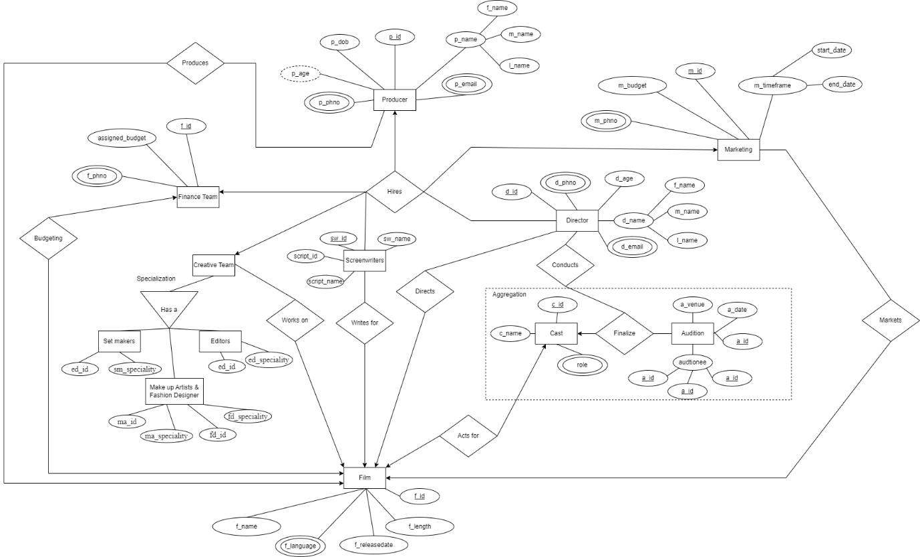

**Relational Database**

**One** Producer hires **Many** Directors

|  |  |  |  |  |
| --- | --- | --- | --- | --- |
| p_id | f_name | m_name | l_name | p_age |
|  |  |  |  |  |

|  |  |
| --- | --- |
| p_id | p_email |
|  |  |

|  |  |
| --- | --- |
| p_id | p_phno |
|  |  |

|  |  |
| --- | --- |
| p_id | d_id |
|  |  |

|  |  |  |  |  |
| --- | --- | --- | --- | --- |
| d_id | f_name | m_name | l_name | d_age |
|  |  |  |  |  |

|  |  |
| --- | --- |
| d_id | d_email |
|  |  |

|  |  |
| --- | --- |
| d_id | d_phno |
|  |  |

**One** Producer hires **One** Marketing Team.

|  |  |  |  |  |
| --- | --- | --- | --- | --- |
| p_id | f_name | m_name | l_name | p_age |
|  |  |  |  |  |

|  |  |
| --- | --- |
| p_id | p_email |
|  |  |

|  |  |
| --- | --- |
| p_id | p_phno |
|  |  |

|  |  |
| --- | --- |
| p_id | m_id |
|  |  |

|  |  |  |  |
| --- | --- | --- | --- |
| m_id | m_budget | Start_date | Start_date |
|  |  |  |  |

|  |  |
| --- | --- |
| m_id | p_phno |
|  |  |

**One** Producer hires **One** Finance Team.

|  |  |  |  |  |
| --- | --- | --- | --- | --- |
| p_id | f_name | m_name | l_name | p_age |
|  |  |  |  |  |

|  |  |
| --- | --- |
| p_id | p_email |
|  |  |

|  |  |
| --- | --- |
| p_id | p_phno |
|  |  |

|  |  |
| --- | --- |
| p_id | fi_id |
|  |  |

|  |  |
| --- | --- |
| fi_id | assigned_budget |
|  |  |

|  |  |
| --- | --- |
| p_id | p_phno |
|  |  |

**One** Producer hires **One** Creative Team

|  |  |  |  |  |
| --- | --- | --- | --- | --- |
| p_id | f_name | m_name | l_name | p_age |
|  |  |  |  |  |

|  |  |
| --- | --- |
| p_id | p_email |
|  |  |

|  |  |
| --- | --- |
| p_id | p_phno |
|  |  |

|  |  |  |  |
| --- | --- | --- | --- |
| p_id | sm_id | ma_id | ed_id |
|  |  |  |  |

Creative Team

Set Makers

|  |  |
| --- | --- |
| sm_id | sm_speciality |
|  |  |

Make-up artists & fashion designers

|  |  |  |  |
| --- | --- | --- | --- |
| ma_id | ma_speciality | fd_id | fd_id |
|  |  |  |  |

Editors

|  |  |
| --- | --- |
| ed_id | ed_speciality |
|  |  |

**One** Producer hires **Many** Screenwriters

|  |  |  |  |  |
| --- | --- | --- | --- | --- |
| p_id | f_name | m_name | l_name | p_age |
|  |  |  |  |  |

|  |  |
| --- | --- |
| p_id | p_email |
|  |  |

|  |  |
| --- | --- |
| p_id | p_phno |
|  |  |

|  |  |
| --- | --- |
| p_id | sw_id |
|  |  |

|  |  |  |  |
| --- | --- | --- | --- |
| sw_id | sw_name | script_id | script_id |
|  |  |  |  |

**One** Producer Produces **One** Film

|  |  |  |  |  |
| --- | --- | --- | --- | --- |
| p_id | f_name | m_name | l_name | p_age |
|  |  |  |  |  |

|  |  |
| --- | --- |
| p_id | p_email |
|  |  |

|  |  |
| --- | --- |
| p_id | p_phno |
|  |  |

|  |  |
| --- | --- |
| p_id | f_id |
|  |  |

|  |  |  |  |  |
| --- | --- | --- | --- | --- |
| f_id | f_name | f_release_date | f_length | f_language |
|  |  |  |  |  |

**Many** Directors Directs **One** Film

|  |  |  |  |  |
| --- | --- | --- | --- | --- |
| d_id | f_name | m_name | l_name | d_age |
|  |  |  |  |  |

|  |  |
| --- | --- |
| d_id | d_email |
|  |  |

|  |  |
| --- | --- |
| d_id | d_phno |
|  |  |

|  |  |
| --- | --- |
| d_id | f_id |
|  |  |

|  |  |  |  |  |
| --- | --- | --- | --- | --- |
| f_id | f_name | f_release_date | f_length | f_language |
|  |  |  |  |  |

**Many** Directors Conducts **Many** Auditions

|  |  |  |  |  |
| --- | --- | --- | --- | --- |
| d_id | f_name | m_name | l_name | d_age |
|  |  |  |  |  |

|  |  |
| --- | --- |
| d_id | d_email |
|  |  |

|  |  |
| --- | --- |
| d_id | d_phno |
|  |  |

|  |  |
| --- | --- |
| d_id | a_id |
|  |  |

|  |  |  |
| --- | --- | --- |
| a_id | a_venue | a_date |
|  |  |  |

|  |  |
| --- | --- |
| a_id | audtionee |
|  |  |

**Many** Directors Finalizes **One** Cast

|  |  |  |  |  |
| --- | --- | --- | --- | --- |
| d_id | f_name | m_name | l_name | d_age |
|  |  |  |  |  |

|  |  |
| --- | --- |
| d_id | d_email |
|  |  |

|  |  |
| --- | --- |
| d_id | d_phno |
|  |  |

|  |  |
| --- | --- |
| d_id | c_id |
|  |  |

|  |  |  |
| --- | --- | --- |
| c_id | c_ name | c_role |
|  |  |  |

**One** Cast Acts for **One** Film

|  |  |  |
| --- | --- | --- |
| c_id | c_ name | c_role |
|  |  |  |

|  |  |
| --- | --- |
| c_id | f_id |
|  |  |

|  |  |  |  |  |
| --- | --- | --- | --- | --- |
| f_id | f_name | f_release_date | f_length | f_language |
|  |  |  |  |  |

**One** Marketing Markets **One** Film

|  |  |  |  |
| --- | --- | --- | --- |
| m_id | m_budget | Start_date | Start_date |
|  |  |  |  |

|  |  |
| --- | --- |
| m_id | p_phno |
|  |  |

|  |  |
| --- | --- |
| m_id | f_id |
|  |  |

|  |  |  |  |  |
| --- | --- | --- | --- | --- |
| f_id | f_name | f_release_date | f_length | f_language |
|  |  |  |  |  |

**One** Finance Team is responsible for budgeting **One** Film

|  |  |
| --- | --- |
| fi_id | assigned_budget |
|  |  |

|  |  |
| --- | --- |
| fi_id | fi_phno |
|  |  |

|  |  |
| --- | --- |
| fi_id | f_id |
|  |  |

|  |  |  |  |  |
| --- | --- | --- | --- | --- |
| f_id | f_name | f_release_date | f_length | f_language |
|  |  |  |  |  |

**Many** Screenwriters Write for **One** Film

|  |  |  |  |
| --- | --- | --- | --- |
| sw_id | sw_name | script_id | script_id |
|  |  |  |  |

|  |  |
| --- | --- |
| sw_id | f_id |
|  |  |

|  |  |  |  |  |
| --- | --- | --- | --- | --- |
| f_id | f_name | f_release_date | f_length | f_language |
|  |  |  |  |  |

**Many** Creative Team Works on **One** Film

Creative Team

Set Makers

|  |  |
| --- | --- |
| sm_id | sm_speciality |
|  |  |

Make-up artists & fashion designers

|  |  |  |  |
| --- | --- | --- | --- |
| ma_id | ma_speciality | fd_id | fd_id |
|  |  |  |  |

Editors

|  |  |
| --- | --- |
| ed_id | ed_id |
|  |  |

|  |  |  |  |
| --- | --- | --- | --- |
| sm_id | ma_id | ed_id | f_id |
|  |  |  |  |

|  |  |  |  |  |
| --- | --- | --- | --- | --- |
| f_id | f_name | f_release_date | f_length | f_language |
|  |  |  |  |  |